 | QCRI,  Al Rayyan,  Doha, Qatar
Summer Internship Report
Educational Game App
Date: 25th Jun, 2018
Emil Jacob
BCS 1st Year
School of Computer Science
Carnegie Mellon University Qatar
Executive Summary

My two-month Industrial Internship Program work term was with the Qatar Computing Research Institute, Doha, Qatar. I was involved in developing educational gaming app during my work term, all of which will be outlined in this report. This report will cover some background information on the projects I was involved in, as well as details on how the projects were developed.
There are two major projects that I had a significant role in.
The first project involved gaining a good understanding of an IBM product called Content Manager. My task was to study its capabilities from the point of view of a data management solution in the e-Gov system. My task was to
- Understand the product,
- How to develop applications using Content Manager,
- Create a prototype eGov Application on top of it.

One of the important achievements of this project was the development of a new Programming API over the Content Manger Programming API which provides many features and supports the eGov concept of “Middleware”. The major benefits of this API are:
- It greatly simplifies the task of developing applications on top of Content Manager.
- It provides additional functionality in Content Manager, which would be a requirement for eGov project.
- It supports a layered architecture by which new capabilities can be added to the Content Manager API by implementing the required functionality as layers above the AP

An application was finally developed using the above API to demonstrate its usefulness. It was a prototype solution to a real life problem known as Inner Line Permit, which occurs in eastern states of India like Arunachal Pradesh.

The second project was on designing and implementing Audit Trails in Distributed Database Environments such as that of eGov. Audit Trail can be described as electronic evidence that can be used to trace transactions to verify their validity and accuracy. It gathers data about activity in the system and analyzes it to discover security violations.
In this project we worked on some issues regarding Audit Trails in such an environment and some solutions were proposed.
I acquired many new technical skills throughout my work term. I acquired new knowledge in the area of Distributed Databases. I also brushed up my Visual C++ skills while making the Content Manager application. Then I got introduced to the area of research and how to approach it. Most importantly, the work experience was very good which included good fellowship, cooperative teamwork and accepting responsibilities.
Although I spent a lot of time learning new things, I found that I was well trained in certain areas that helped me substantially in my projects. Many programming skills that I used in my projects, such as programming style and design, were ones that I had acquired during my studies in Computing Science.

This report concludes with my overall impressions of my work experience as well as my opinion of the Industrial Internship Program in general.

Table of contents

1 Acknowledgements 3
2 OVERVIEW AND SCOPE OF THE PROJECT 4
3 Project - I: Content Manager 7
3.1 Project Background and Scope 7
3.2 Project's Rationale and Goals 7
3.3 Technical Details and Applicable Issues 8
3.3.1 Installing the Product 8
3.3.2 Understanding Content Manager 8
3.3.3 Overview of the Architecture of Content Manager 8
3.3.4 Features of Content Manager – Brief Summary 10
3.3.5 The Beginners Guide to Content Manager 10
3.3.6 The New Content Manager API 10
3.3.7 The Inner Line Permit Application 12
3.3.8 Future Work 16
3.3.9 Summary 17
4 Project – II: Audit Trail on Distribute Databases 18
4.1 Project Background and Scope 18
4.1.1 eGovernment from audit trail’s perspective 18
4.1.2 What is audit trail ? 18
4.2 Project's Rationale and Goals 19
4.3 Technical Details and Applicable Issues 20
4.3.1 Architectural choices 20
4.4 Requirements for Audit Trail 21
4.5 Solution 22
4.5.1 Reference Architecture of ATA 24
4.6 Future Work 25
4.7 Summary 25
5 Learning From the Internship Program 25
6 Applying My University Skills 26
7 Appendices 27
7.1 Appendix A : Code for the App screens 27
7.2 Appendix B : App page screenshots 31
7.3 Appendix C : Flowchart for the App 32

Acknowledgements
During my summer internship , the staff at QCRI and people guiding me were very helpful and extended their valuable guidance and help whenever required for the projects which I worked on.
I am very thankful to my guide Dr.Yifan Zhang for his invaluable guidance and advice during my Summer Internship.
I am thankful to Dr. Eman Fituri for her guidance and friendly support during my stay at QCRI.
I am also very greatful to Shaheer Bakali for great cooperation and help especially in the project and my final presentation.
Overall , the above team made my stay at QCRI an enjoyable one and I am greatful to them for making it so.

Overview and Scope of the Project

This project is an educational connecting dot game called “Connect and Guess”. In this game, the player is given a canvas in which an image with many dots is preloaded. The player has to connect dotted lines, which then reveal a particular animal that the player has to guess. This can be done through the following ways:
- Choose the right animal name from choices.
- Write down the right animal name in text.
- Speak the right animal name through speech recognition.
This project is aimed as a way for kids to enjoy the learning process, and for them to develop a fruitful experience learning about different animals. This is a way for kids to interact with the rapidly growing technology, which are meant to help facilitate their learning.

Project Tools and Specifications

Operating System | : | Windows 10
Programming tools | : | HTML5, Javascript, Jquery
Supported Operating System | : | Windows 10, IOS, Android
Supported browser | : | Google Chrome

Goals for this Project
For this project, I accomplished the following tasks:
- Setting up development environment (using Jquery).
- Develop canvas (using HTML and Javascript).
- Handling title (Connect and Guess) and flow of game (as described in Appendix C).
- Finishing up the Game App.

Learning From the Internship Program
The Internship program was quite beneficial for me. It helped me in improving team work, technical skills and enhanced my knowledge in new areas as follows ;

- I gained new knowledge in the area of HTML Canvas and Javascript, especially in the area of binding multiple programs together, and working in a cross-language environment.
- Learned about the development stages of a project (from planning, to the execution, and the finalizing).

Work Experience
My internship was quite satisfactory in terms of work environment. The team I worked with was very friendly and helped me in solving problems. New experiences include
- Teamwork
In these projects 2-3 people worked together thus providing enough opportunity for proper teamwork and coordination. This was a good experience for me as the team was very cooperative and understanding.

- Responsibility and keeping commitments
The importance of honoring commitments and time of others was an important thing, which I learnt as a summer Intern. Especially, while working as a team it is very important to keep these points in mind.

Applying My University Skills
My education at CMU was very helpful in my Internship. The programming skills which I developed there were very helpful in developing the API and the Game Application. The courses 15112 (Fundamentals of Programming) and 15122 (Principles of Imperative Computation) were especially helpful in this regard. These two courses helped me to develop my problem solving skills, as well as the basic approach to a program (including the steps behind it), which are very important to a developer like myself.

Game App Program

- Menu Screen

<!DOCTYPE html PUBLIC "-//W3C//DTD//XHTML 1.0
Transitional//EN"
"http://www.w3.org/TR/xhtml1/DTD/xhtml1-transitional.dtd">

<html xmlns="http://www.w3.org/1999/xhtml"
xml : lang="en" lang="en">
<head>

<meta http-equiv="Content-Type" content="text/html; charset=iso-8859-1" />

<title>Educational Game App</title>

<script type="text/javascript">
/* <![CDATA[ */
function sub() {
window.location.href = site;
}
function goTo(URL) {
site = URL;
}
/* ]]> */
</script>

</head>

<body align="center" background="http://www.morfinmagic.com/html/images/Blue%20Star%20Background.jpg">
<br><br><br><br><br>
<font size="12" color="white"> Welcome to the Connect and Guess Game!</font><br><br>
<font size="10"color="white"> Please select how you want to play this game below.</font><br>
<form name="frmSite">
<input type="radio" name="site" onchange="if(this.checked){goTo('App/canvas-mcq.htm')}"/>
<font color="white" size="8">Choices</font><br><br>
<input type="radio" name="site" onchange="if(this.checked){goTo('App/canvas-text.htm')}"/>
<font color="white" size="8">Text</font><br><br>
<input type="radio" name="site" onchange="if(this.checked){goTo('App/canvas-speech.htm')}"/>
<font color="white" size="8">Speech</font><br><br>
<input type="Button" value="Submit" onclick="sub()" />
</form>
</body>

</html>

- Game Screen (MCQ)

<!DOCTYPE html>
<html lang="en">
<head>
<meta charset="utf-8" />
<title>Desktops and Tablets</title>

<script type="text/javascript" src="https://ajax.googleapis.com/ajax/libs/jquery/1.7.1/jquery.min.js"></script>

<script type="text/javascript">

var image_list=["Images/image1.png","Images/image2.png","Images/image3.png","Images/image4.png","Images/image5.png","Images/image6.png","Images/image7.png","Images/image8.png","Images/image9.png","Images/image10.png","Images/image11.png","Images/image12.png","Images/image13.png","Images/image14.png","Images/image15.png","Images/image16.png","Images/image17.png","Images/image18.png","Images/image19.png","Images/image20.png"];
var answer_list=["Bat","Bear","Butterfly","Cat","Duck","Fish","Hippo","Lion","Shark","Snail","Cow","Frog","Fox","Mouse","Owl","Rabbit","Snake","Squirrel","Swan","Whale"];
var i=0;
function random_list (i) {
var random1=0; var random2=0; var random3=0;
while (random1===random2||random1===random3||random2===random3) {
random1=Math.floor(Math.random()*image_list.length);
random2=Math.floor(Math.random()*image_list.length);
random3=Math.floor(Math.random()*image_list.length);
}
if (random1!==i && random2!==i && random3!==i) {
random1=i;
}
return [random1,random2,random3];
}

function disorder(p){
var i, pos, temp;
for(i=0;i<100;i++){
pos = Math.random()*p.length|0;
temp=p[pos];
p.splice(pos,1);
p.push(temp);
}
}
//Above two functions random the answer choices for the MCQ. First function creates random list, and second function reorders the random list.
$(document).ready(function () {
initialize();
});

//Draws a image from the list of dot images in the folder, with its URL as argument.
function Draw(src) {
var sigCanvas = document.getElementById("canvasSignature");
var context = sigCanvas.getContext("2d");
var ImageObj= document.createElement("img");
ImageObj.onload = function() {
fitImageOn(sigCanvas, ImageObj);
};

function fitImageOn(canvas, imageObj) {
context.clearRect(0, 0, canvas.width, canvas.height);

var imageDimensionRatio = imageObj.width / imageObj.height;
var canvasDimensionRatio = canvas.width / canvas.height;
var renderableHeight, renderableWidth, xStart, yStart;
if(imageDimensionRatio < canvasDimensionRatio) {
renderableHeight = canvas.height;
renderableWidth = imageObj.width * (renderableHeight / imageObj.height);
xStart = (canvas.width - renderableWidth) / 2;
yStart = 0;
} else if(imageDimensionRatio > canvasDimensionRatio) {
renderableWidth = canvas.width;
renderableHeight = imageObj.height * (renderableWidth / imageObj.width);
xStart = 0;
yStart = (canvas.height - renderableHeight) / 2;
} else {
renderableHeight = canvas.height;
renderableWidth = canvas.width;
xStart = 0;
yStart = 0;
}
context.drawImage(imageObj, xStart, yStart, renderableWidth, renderableHeight);
};
ImageObj.src=src;
context.strokeStyle = 'Black';

// This will be defined on a TOUCH device such as iPad or Android, etc.
var is_touch_device = 'ontouchstart' in document.documentElement;

if (is_touch_device) {
// create a drawer which tracks touch movements
var drawer = {
isDrawing: false,
touchstart: function (coors) {
context.beginPath();
context.moveTo(coors.x, coors.y);
this.isDrawing = true;
},
touchmove: function (coors) {
if (this.isDrawing) {
context.lineTo(coors.x, coors.y);
context.stroke();
}
},
touchend: function (coors) {
if (this.isDrawing) {
this.touchmove(coors);
this.isDrawing = false;
}
}
};

// create a function to pass touch events and coordinates to drawer
function draw(event) {

// get the touch coordinates. Using the first touch in case of multi-touch
var coors = {
x: event.targetTouches[0].pageX,
y: event.targetTouches[0].pageY
};

// Now we need to get the offset of the canvas location
var obj = sigCanvas;

if (obj.offsetParent) {
// Every time we find a new object, we add its offsetLeft and offsetTop to curleft and curtop.
do {
coors.x -= obj.offsetLeft;
coors.y -= obj.offsetTop;
}
// The while loop can be "while (obj = obj.offsetParent)" only, which does return null
// when null is passed back, but that creates a warning in some editors (i.e. VS2010).
while ((obj = obj.offsetParent) != null);
}

// pass the coordinates to the appropriate handler
drawer[event.type](coors);
}

// attach the touchstart, touchmove, touchend event listeners.
sigCanvas.addEventListener('touchstart', draw, false);
sigCanvas.addEventListener('touchmove', draw, false);
sigCanvas.addEventListener('touchend', draw, false);

// prevent elastic scrolling
sigCanvas.addEventListener('touchmove', function (event) {
event.preventDefault();
}, false);
}
else {

// start drawing when the mousedown event fires, and attach handlers to
// draw a line to wherever the mouse moves to
$("#canvasSignature").mousedown(function (mouseEvent) {
var position = getPosition(mouseEvent, sigCanvas);

context.moveTo(position.X, position.Y);
context.beginPath();

// attach event handlers
$(this).mousemove(function (mouseEvent) {
drawLine(mouseEvent, sigCanvas, context);
}).mouseup(function (mouseEvent) {
finishDrawing(mouseEvent, sigCanvas, context);
}).mouseout(function (mouseEvent) {
finishDrawing(mouseEvent, sigCanvas, context);
});
});

}
}

// works out the X, Y position of the click inside the canvas from the X, Y position on the page
function getPosition(mouseEvent, sigCanvas) {
var x, y;
if (mouseEvent.pageX != undefined && mouseEvent.pageY != undefined) {
x = mouseEvent.pageX;
y = mouseEvent.pageY;
} else {
x = mouseEvent.clientX + document.body.scrollLeft + document.documentElement.scrollLeft;
y = mouseEvent.clientY + document.body.scrollTop + document.documentElement.scrollTop;
}

return { X: x - sigCanvas.offsetLeft, Y: y - sigCanvas.offsetTop };
}

function initialize() {
// Initializes the canvas and the webpage.
Draw(image_list[i]);
var random = random_list(i);
disorder(random);
var answers=document.getElementsByName("answer");
answers[0].value=answer_list[random[0]];
answers[1].value=answer_list[random[1]];
answers[2].value=answer_list[random[2]];
answers[0].checked=false;
answers[1].checked=false;
answers[2].checked=false;
document.getElementById("answer1").innerHTML=answer_list[random[0]];
document.getElementById("answer2").innerHTML=answer_list[random[1]];
document.getElementById("answer3").innerHTML=answer_list[random[2]];
}

// draws a line to the x and y coordinates of the mouse event inside
// the specified element using the specified context
function drawLine(mouseEvent, sigCanvas, context) {
var position = getPosition(mouseEvent, sigCanvas);

context.lineTo(position.X, position.Y);
context.stroke();
}

// draws a line from the last coordiantes in the path to the finishing
// coordinates and unbind any event handlers which need to be preceded
// by the mouse down event
function finishDrawing(mouseEvent, sigCanvas, context) {

context.closePath();

// unbind any events which could draw
$(sigCanvas).unbind("mousemove")
.unbind("mouseup")
.unbind("mouseout");
}

function equal() {
//Compares the correct answer to the inputted answer.
var answers=document.getElementsByName('answer');
var answer="";
for (var j=0; j<answers.length; j++) {
if (answers[j].checked) {
answer=answers[j].value;
break;
}
}
if (answer!=="") {answer=answer.substring(0,1).toUpperCase()+answer.substring(1,answer.length).toLowerCase(); }
var image=answer_list[i];
if (answer==="") {
alert("Please select something"); }
else if (answer===image) {
window.open('Corr-Incorr/correct.htm');
i++;
if (i>=image_list.length) {
window.open('Corr-Incorr/congratulations.htm');
}
else {
initialize(); }
}
else {
window.open('Corr-Incorr/incorrect.htm'); }
}

</script>

</head>

<body align="center" background="http://www.morfinmagic.com/html/images/Blue%20Star%20Background.jpg">
<font color="white">Select the correct choice among a list of three</font>
<div id="canvasDiv">
<!-- It's bad practice (to me) to put your CSS here. I'd recommend the use of a CSS file! -->
<canvas id="canvasSignature" width="600px" height="600px" style="border:2px solid #000000;"></canvas>
</div>
<form>
<div id="answer-value">
<input type="radio" name="answer" value="">
<font color="white" id="answer1"></font>
<input type="radio" name="answer" value="">
<font color="white" id="answer2"></font>
<input type="radio" name="answer" value="">
<font color="white" id="answer3"></font>
</div>
</form>
<button onclick="equal()">Submit</button>
<button onclick="initialize()">Clear</button>
</body>
</html>

- Game Screen (Text)

<!DOCTYPE html>
<html lang="en">
<head>
<meta charset="utf-8" />
<title>Connect and Guess-Text</title>

<script type="text/javascript" src="https://ajax.googleapis.com/ajax/libs/jquery/1.7.1/jquery.min.js"></script>

<script type="text/javascript">

var image_list=["Images/image1.png","Images/image2.png","Images/image3.png","Images/image4.png","Images/image5.png","Images/image6.png","Images/image7.png","Images/image8.png","Images/image9.png","Images/image10.png","Images/image11.png","Images/image12.png","Images/image13.png","Images/image14.png","Images/image15.png","Images/image16.png","Images/image17.png","Images/image18.png","Images/image19.png","Images/image20.png"];
var answer_list=["Bat","Bear","Butterfly","Cat","Duck","Fish","Hippo","Lion","Shark","Snail","Cow","Frog","Fox","Mouse","Owl","Rabbit","Snake","Squirrel","Swan","Whale"];
var i=0;

$(document).ready(function () {
initialize();
});

function Draw(src) {
var sigCanvas = document.getElementById("canvasSignature");
var context = sigCanvas.getContext("2d");
var ImageObj= document.createElement("img");
ImageObj.onload = function() {
fitImageOn(sigCanvas, ImageObj);
};

function fitImageOn(canvas, imageObj) {
context.clearRect(0, 0, canvas.width, canvas.height);

var imageDimensionRatio = imageObj.width / imageObj.height;
var canvasDimensionRatio = canvas.width / canvas.height;
var renderableHeight, renderableWidth, xStart, yStart;
if(imageDimensionRatio < canvasDimensionRatio) {
renderableHeight = canvas.height;
renderableWidth = imageObj.width * (renderableHeight / imageObj.height);
xStart = (canvas.width - renderableWidth) / 2;
yStart = 0;
} else if(imageDimensionRatio > canvasDimensionRatio) {
renderableWidth = canvas.width;
renderableHeight = imageObj.height * (renderableWidth / imageObj.width);
xStart = 0;
yStart = (canvas.height - renderableHeight) / 2;
} else {
renderableHeight = canvas.height;
renderableWidth = canvas.width;
xStart = 0;
yStart = 0;
}
context.drawImage(imageObj, xStart, yStart, renderableWidth, renderableHeight);
};
ImageObj.src=src;
context.strokeStyle = 'Black';

// This will be defined on a TOUCH device such as iPad or Android, etc.
var is_touch_device = 'ontouchstart' in document.documentElement;

if (is_touch_device) {
// create a drawer which tracks touch movements
var drawer = {
isDrawing: false,
touchstart: function (coors) {
context.beginPath();
context.moveTo(coors.x, coors.y);
this.isDrawing = true;
},
touchmove: function (coors) {
if (this.isDrawing) {
context.lineTo(coors.x, coors.y);
context.stroke();
}
},
touchend: function (coors) {
if (this.isDrawing) {
this.touchmove(coors);
this.isDrawing = false;
}
}
};

// create a function to pass touch events and coordinates to drawer
function draw(event) {

// get the touch coordinates. Using the first touch in case of multi-touch
var coors = {
x: event.targetTouches[0].pageX,
y: event.targetTouches[0].pageY
};

// Now we need to get the offset of the canvas location
var obj = sigCanvas;

if (obj.offsetParent) {
// Every time we find a new object, we add its offsetLeft and offsetTop to curleft and curtop.
do {
coors.x -= obj.offsetLeft;
coors.y -= obj.offsetTop;
}
// The while loop can be "while (obj = obj.offsetParent)" only, which does return null
// when null is passed back, but that creates a warning in some editors (i.e. VS2010).
while ((obj = obj.offsetParent) != null);
}

// pass the coordinates to the appropriate handler
drawer[event.type](coors);
}

// attach the touchstart, touchmove, touchend event listeners.
sigCanvas.addEventListener('touchstart', draw, false);
sigCanvas.addEventListener('touchmove', draw, false);
sigCanvas.addEventListener('touchend', draw, false);

// prevent elastic scrolling
sigCanvas.addEventListener('touchmove', function (event) {
event.preventDefault();
}, false);
}
else {

// start drawing when the mousedown event fires, and attach handlers to
// draw a line to wherever the mouse moves to
$("#canvasSignature").mousedown(function (mouseEvent) {
var position = getPosition(mouseEvent, sigCanvas);

context.moveTo(position.X, position.Y);
context.beginPath();

// attach event handlers
$(this).mousemove(function (mouseEvent) {
drawLine(mouseEvent, sigCanvas, context);
}).mouseup(function (mouseEvent) {
finishDrawing(mouseEvent, sigCanvas, context);
}).mouseout(function (mouseEvent) {
finishDrawing(mouseEvent, sigCanvas, context);
});
});

}
}

// works out the X, Y position of the click inside the canvas from the X, Y position on the page
function getPosition(mouseEvent, sigCanvas) {
var x, y;
if (mouseEvent.pageX != undefined && mouseEvent.pageY != undefined) {
x = mouseEvent.pageX;
y = mouseEvent.pageY;
} else {
x = mouseEvent.clientX + document.body.scrollLeft + document.documentElement.scrollLeft;
y = mouseEvent.clientY + document.body.scrollTop + document.documentElement.scrollTop;
}

return { X: x - sigCanvas.offsetLeft, Y: y - sigCanvas.offsetTop };
}

function initialize() {
//Initializes the canvas and the webpage
Draw(image_list[i]);
document.getElementById('answer').value="";
}

// draws a line to the x and y coordinates of the mouse event inside
// the specified element using the specified context
function drawLine(mouseEvent, sigCanvas, context) {

var position = getPosition(mouseEvent, sigCanvas);

context.lineTo(position.X, position.Y);
context.stroke();
}

// draws a line from the last coordiantes in the path to the finishing
// coordinates and unbind any event handlers which need to be preceded
// by the mouse down event
function finishDrawing(mouseEvent, sigCanvas, context) {

context.closePath();

// unbind any events which could draw
$(sigCanvas).unbind("mousemove")
.unbind("mouseup")
.unbind("mouseout");
}

function equal() {
//Compares the correct answer to the inputted answer.
var answer=document.getElementById('answer').value;
if (answer!=="") {answer=answer.substring(0,1).toUpperCase()+answer.substring(1,answer.length).toLowerCase(); }
var image=answer_list[i];
if (answer==="") {
alert("Please type something"); }
else if (answer===image) {
window.open('Corr-Incorr/correct.htm');
i++;
if (i>=image_list.length) {
window.open('Corr-Incorr/congratulations.htm');
}
else{
initialize(); }
}
else {
window.open('Corr-Incorr/incorrect.htm'); }
}
</script>

</head>

<body align="center" background="http://www.morfinmagic.com/html/images/Blue%20Star%20Background.jpg">
<font size="10" color="white">Enter the correct answer in the text field below</font>
<div id="canvasDiv">
<!-- It's bad practice (to me) to put your CSS here. I'd recommend the use of a CSS file! -->
<canvas id="canvasSignature" width="600px" height="600px" style="border:2px solid #000000;"></canvas>
</div>
<input type="text" id="answer">
<button onclick="equal()">Submit</button>
<button onclick="initialize()">Clear</button>
<form id="p"></form>
</body>
</html>

- Game Screen (Speech)

<!DOCTYPE html>
<html lang="en">
<head>
<meta charset="utf-8" />
<title>connect and Guess-Speech</title>

<script type="text/javascript" src="https://ajax.googleapis.com/ajax/libs/jquery/1.7.1/jquery.min.js"></script>

<script type="text/javascript">

var image_list=["Images/image1.png","Images/image2.png","Images/image3.png","Images/image4.png","Images/image5.png","Images/image6.png","Images/image7.png","Images/image8.png","Images/image9.png","Images/image10.png","Images/image11.png","Images/image12.png","Images/image13.png","Images/image14.png","Images/image15.png","Images/image16.png","Images/image17.png","Images/image18.png","Images/image19.png","Images/image20.png"];
var answer_list=["Bat","Bear","Butterfly","Cat","Duck","Fish","Hippo","Lion","Shark","Snail","Cow","Frog","Fox","Mouse","Owl","Rabbit","Snake","Squirrel","Swan","Whale"];
var i=0;

$(document).ready(function () {
initialize();
});

function Draw(src) {
var sigCanvas = document.getElementById("canvasSignature");
var context = sigCanvas.getContext("2d");
var ImageObj= document.createElement("img");
ImageObj.onload = function() {
fitImageOn(sigCanvas, ImageObj);
};

function fitImageOn(canvas, imageObj) {
context.clearRect(0, 0, canvas.width, canvas.height);

var imageDimensionRatio = imageObj.width / imageObj.height;
var canvasDimensionRatio = canvas.width / canvas.height;
var renderableHeight, renderableWidth, xStart, yStart;
if(imageDimensionRatio < canvasDimensionRatio) {
renderableHeight = canvas.height;
renderableWidth = imageObj.width * (renderableHeight / imageObj.height);
xStart = (canvas.width - renderableWidth) / 2;
yStart = 0;
} else if(imageDimensionRatio > canvasDimensionRatio) {
renderableWidth = canvas.width;
renderableHeight = imageObj.height * (renderableWidth / imageObj.width);
xStart = 0;
yStart = (canvas.height - renderableHeight) / 2;
} else {
renderableHeight = canvas.height;
renderableWidth = canvas.width;
xStart = 0;
yStart = 0;
}
context.drawImage(imageObj, xStart, yStart, renderableWidth, renderableHeight);
};
ImageObj.src=src;
context.strokeStyle = 'Black';

// This will be defined on a TOUCH device such as iPad or Android, etc.
var is_touch_device = 'ontouchstart' in document.documentElement;

if (is_touch_device) {
// create a drawer which tracks touch movements
var drawer = {
isDrawing: false,
touchstart: function (coors) {
context.beginPath();
context.moveTo(coors.x, coors.y);
this.isDrawing = true;
},
touchmove: function (coors) {
if (this.isDrawing) {
context.lineTo(coors.x, coors.y);
context.stroke();
}
},
touchend: function (coors) {
if (this.isDrawing) {
this.touchmove(coors);
this.isDrawing = false;
}
}
};

// create a function to pass touch events and coordinates to drawer
function draw(event) {

// get the touch coordinates. Using the first touch in case of multi-touch
var coors = {
x: event.targetTouches[0].pageX,
y: event.targetTouches[0].pageY
};

// Now we need to get the offset of the canvas location
var obj = sigCanvas;

if (obj.offsetParent) {
// Every time we find a new object, we add its offsetLeft and offsetTop to curleft and curtop.
do {
coors.x -= obj.offsetLeft;
coors.y -= obj.offsetTop;
}
// The while loop can be "while (obj = obj.offsetParent)" only, which does return null
// when null is passed back, but that creates a warning in some editors (i.e. VS2010).
while ((obj = obj.offsetParent) != null);
}

// pass the coordinates to the appropriate handler
drawer[event.type](coors);
}

// attach the touchstart, touchmove, touchend event listeners.
sigCanvas.addEventListener('touchstart', draw, false);
sigCanvas.addEventListener('touchmove', draw, false);
sigCanvas.addEventListener('touchend', draw, false);

// prevent elastic scrolling
sigCanvas.addEventListener('touchmove', function (event) {
event.preventDefault();
}, false);
}
else {

// start drawing when the mousedown event fires, and attach handlers to
// draw a line to wherever the mouse moves to
$("#canvasSignature").mousedown(function (mouseEvent) {
var position = getPosition(mouseEvent, sigCanvas);

context.moveTo(position.X, position.Y);
context.beginPath();

// attach event handlers
$(this).mousemove(function (mouseEvent) {
drawLine(mouseEvent, sigCanvas, context);
}).mouseup(function (mouseEvent) {
finishDrawing(mouseEvent, sigCanvas, context);
}).mouseout(function (mouseEvent) {
finishDrawing(mouseEvent, sigCanvas, context);
});
});

}
}

// works out the X, Y position of the click inside the canvas from the X, Y position on the page
function getPosition(mouseEvent, sigCanvas) {
var x, y;
if (mouseEvent.pageX != undefined && mouseEvent.pageY != undefined) {
x = mouseEvent.pageX;
y = mouseEvent.pageY;
} else {
x = mouseEvent.clientX + document.body.scrollLeft + document.documentElement.scrollLeft;
y = mouseEvent.clientY + document.body.scrollTop + document.documentElement.scrollTop;
}

return { X: x - sigCanvas.offsetLeft, Y: y - sigCanvas.offsetTop };
}

function initialize() {
// Initialize the canvas and the webpage
Draw(image_list[i]);
localStorage.clear();
}

// draws a line to the x and y coordinates of the mouse event inside
// the specified element using the specified context
function drawLine(mouseEvent, sigCanvas, context) {

var position = getPosition(mouseEvent, sigCanvas);

context.lineTo(position.X, position.Y);
context.stroke();
}

// draws a line from the last coordiantes in the path to the finishing
// coordinates and unbind any event handlers which need to be preceded
// by the mouse down event
function finishDrawing(mouseEvent, sigCanvas, context) {

context.closePath();

// unbind any events which could draw
$(sigCanvas).unbind("mousemove")
.unbind("mouseup")
.unbind("mouseout");
}

//Compares the correct answer with the inputted answer.
function equal() {
var answer=localStorage.getItem('answer');
if (answer!=="") {answer=answer.substring(0,1).toUpperCase()+answer.substring(1,answer.length).toLowerCase(); }
var image=answer_list[i];
if (answer==="") {
alert("Please say something"); }
else if (answer===image) {
window.open('Corr-Incorr/correct.htm');
i++;
if (i>=image_list.length) {
window.open('Corr-Incorr/congratulations.htm');
localStorage.clear();
}
else{
initialize(); }
}
else {
window.open('Corr-Incorr/incorrect.htm'); }
}
</script>

</head>

<body align="center" background="http://www.morfinmagic.com/html/images/Blue%20Star%20Background.jpg">
<font size="10" color="white">Enter the correct answer in the text field below</font>
<div id="canvasDiv">
<!-- It's bad practice (to me) to put your CSS here. I'd recommend the use of a CSS file! -->
<canvas id="canvasSignature" width="600px" height="600px" style="border:2px solid #000000;"></canvas>
</div>
<embed width="600" height="600" src="speech.htm">
<button onclick="equal()">Submit</button>
<button onclick="initialize()">Clear</button>
<form id="p"></form>
</body>
</html>

- Speech.htm (Add-on to the Canvas Speech)

<!DOCTYPE html>
<html>
<head>
<meta charset="UTF-8">
<meta name="viewport" content="width=device-width, initial-scale=1.0"/>
<title>Web Speech API Demo</title>
<style>
body
{
max-width: 500px;
margin: 2em auto;
font-size: 20px;
}

h1
{
text-align: center;
}

.buttons-wrapper
{
text-align: center;
}

.hidden
{
display: none;
}

#transcription,
#log
{
display: block;
width: 100%;
height: 5em;
overflow-y: scroll;
border: 1px solid #333333;
line-height: 1.3em;
}

.button-demo
{
padding: 0.5em;
display: inline-block;
margin: 1em auto;
}
</style>
</head>
<body bgcolor="white">
<h2>Transcription</h2>
<textarea id="transcription" readonly="readonly"></textarea>

<span>Results:</span>
<label><input type="radio" name="recognition-type" value="final" checked="checked" /> Final only</label>
<label><input type="radio" name="recognition-type" value="interim" /> Interim</label>

<h3>Log</h3>
<div id="log"></div>

<div class="buttons-wrapper">
<button id="button-play-ws" class="button-demo">Play demo</button>
<button id="button-stop-ws" class="button-demo">Stop demo</button>
<button id="clear-all" class="button-demo">Clear all</button>
</div>
<span id="ws-unsupported" class="hidden">API not supported</span>

<script>
// Test browser support
window.SpeechRecognition = window.SpeechRecognition ||
window.webkitSpeechRecognition ||
null;

if (window.SpeechRecognition === null) {
document.getElementById('ws-unsupported').classList.remove('hidden');
document.getElementById('button-play-ws').setAttribute('disabled', 'disabled');
document.getElementById('button-stop-ws').setAttribute('disabled', 'disabled');
} else {
var recognizer = new window.SpeechRecognition();
var transcription = document.getElementById('transcription');
var log = document.getElementById('log');

// Recogniser doesn't stop listening even if the user pauses
recognizer.continuous = true;

// Start recognising
recognizer.onresult = function(event) {
transcription.textContent = '';

for (var i = event.resultIndex; i < event.results.length; i++) {
if (event.results[i].isFinal) {
transcription.textContent = event.results[i][0].transcript + ' (Confidence: ' + event.results[i][0].confidence + ')';
} else {
transcription.textContent += event.results[i][0].transcript;
}
}
localStorage.setItem('answer',transcription.textContent);
};

// Listen for errors
recognizer.onerror = function(event) {
log.innerHTML = 'Recognition error: ' + event.message + '<br />' + log.innerHTML;
};

document.getElementById('button-play-ws').addEventListener('click', function() {
// Set if we need interim results
recognizer.interimResults = document.querySelector('input[name="recognition-type"][value="interim"]').checked;

try {
recognizer.start();
log.innerHTML = 'Recognition started' + '<br />' + log.innerHTML;
} catch(ex) {
log.innerHTML = 'Recognition error: ' + ex.message + '<br />' + log.innerHTML;
}
});

document.getElementById('button-stop-ws').addEventListener('click', function() {
recognizer.stop();
log.innerHTML = 'Recognition stopped' + '<br />' + log.innerHTML;
});

document.getElementById('clear-all').addEventListener('click', function() {
localStorage.clear();
transcription.textContent = '';
log.textContent = '';
});
}

</script>
</body>
</html>

- Correct Screen

<!DOCTYPE html>
<html>
<body align="center">
<img src="correct.jpg" width=600 height=600>
<font size="10">CORRECT!!!</font>
<embed name="myMusic" loop="true" hidden="true" src="correct.mp3"></embed>
</body>
</html>

- Incorrect Screen

<html>
<body align="center">
<img src="incorrect.jpg" width=600 height=600 alt="Incorrect">
<font size="10">WRONG!!!</font>
<embed name="myMusic" loop="true" hidden="true" src="incorrect.wav"></embed>
</body>
</html>

- Congratulations Screen

<!DOCTYPE html>
<html>
<body align="center">
<img src="congratulations.jpg" width=600 height=600>
<font size="10">CONGRATULATIONS!!! <br /> You have completed the game</font>
<embed name="myMusic" loop="true" hidden="true" src="congratulations.mp3"></embed>
</body>
</html>

Appendix

Appendix A: App Page Screenshots
- Welcome Screen
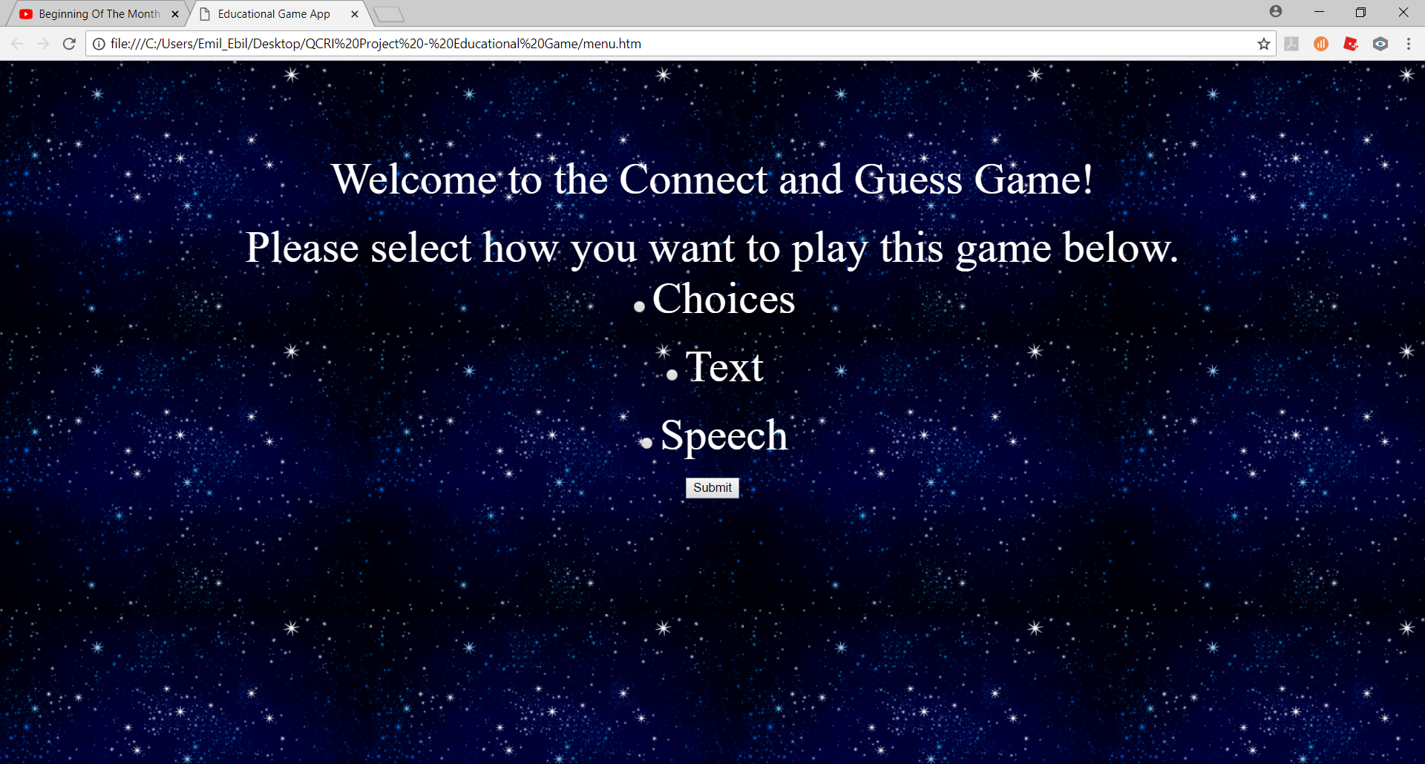

- Game Screen (MCQ)
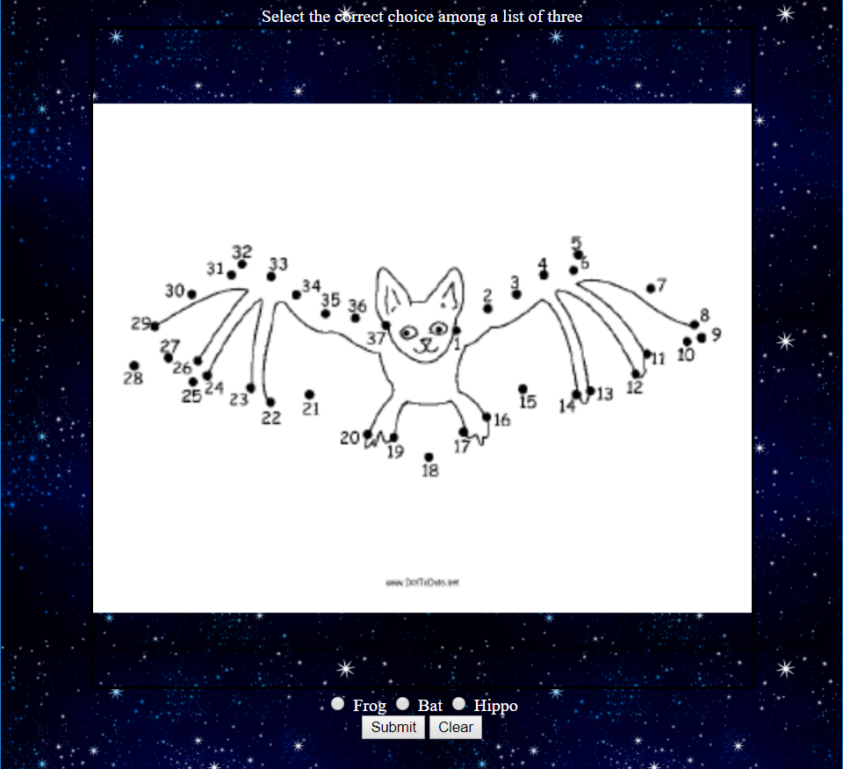

- Game Screen (Text)
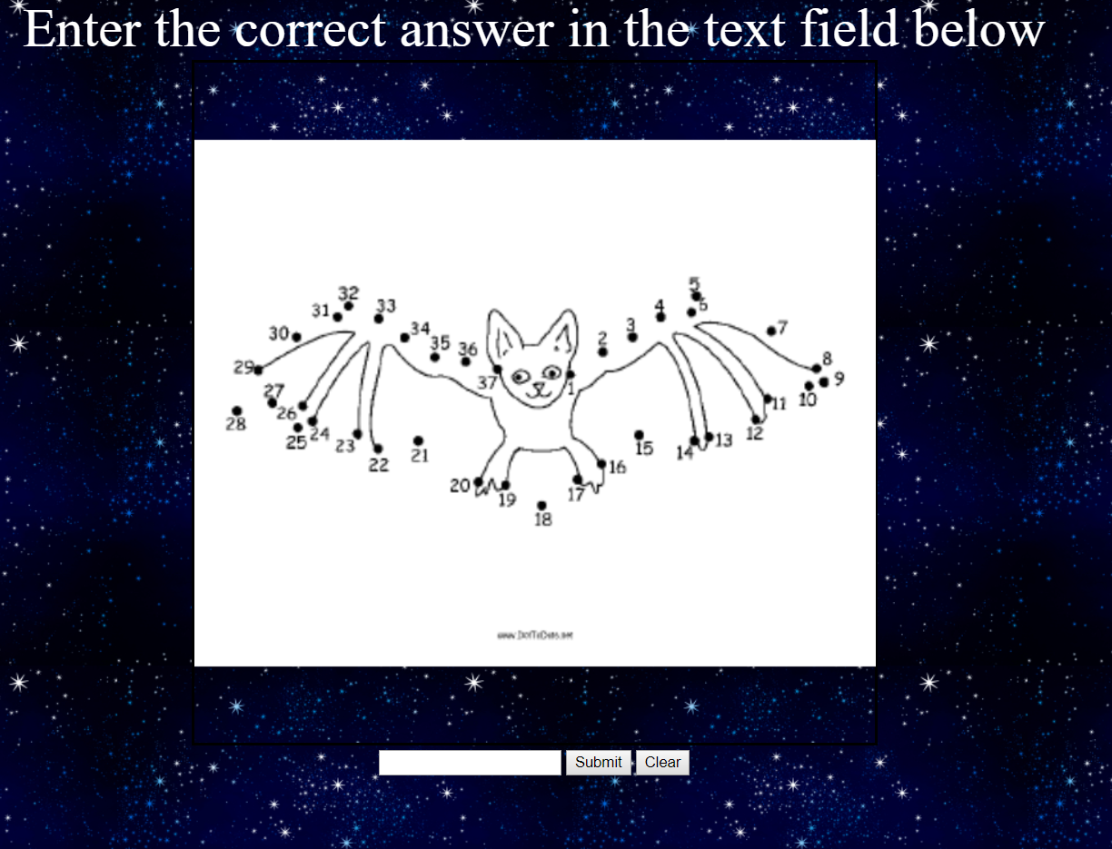

- Game Screen (Speech)
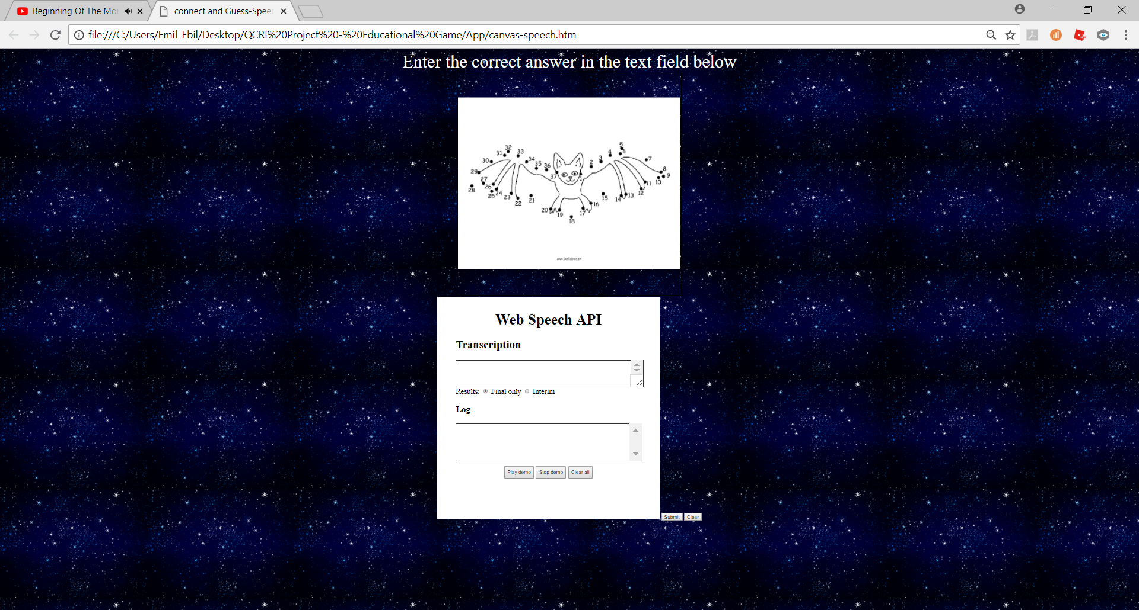

- Results Screens

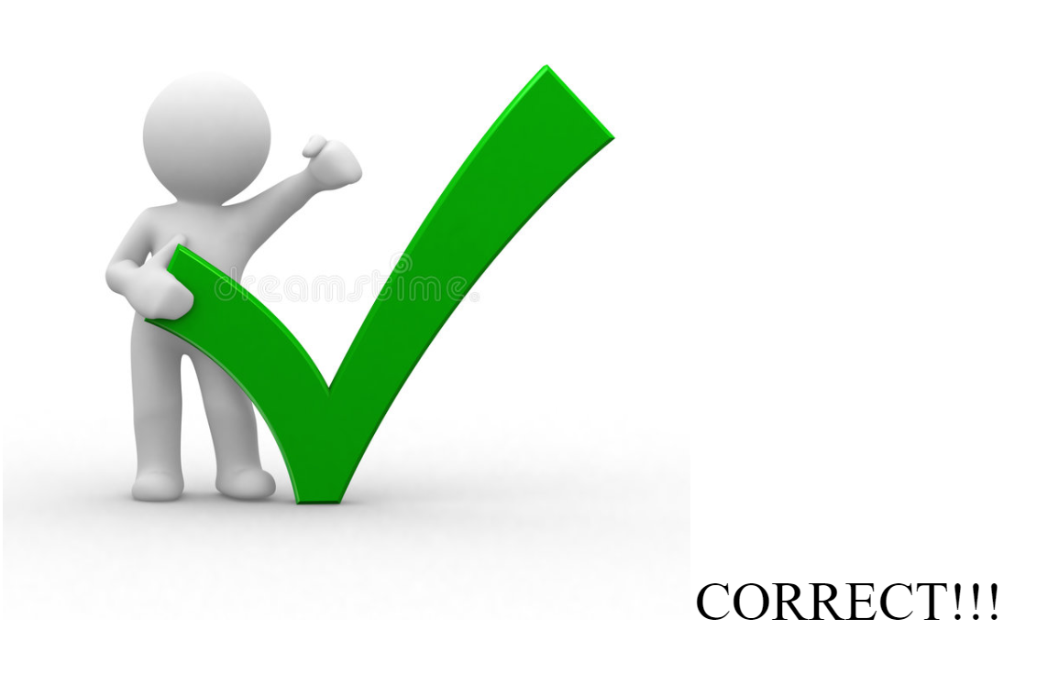
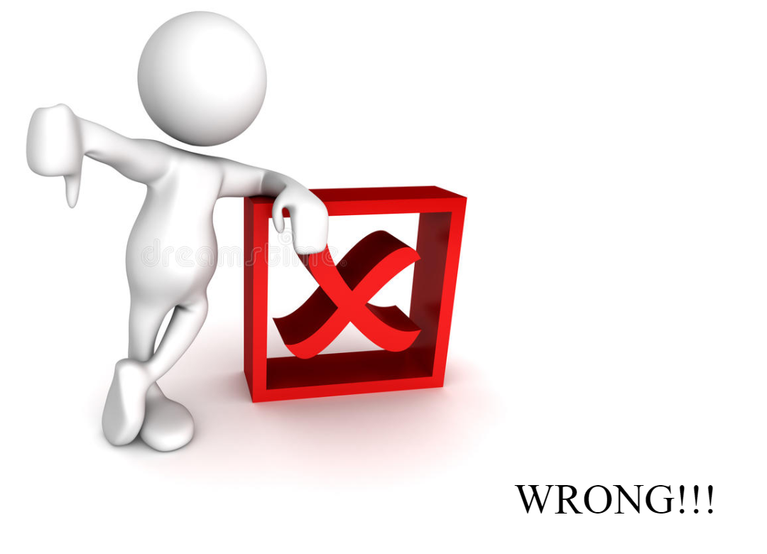
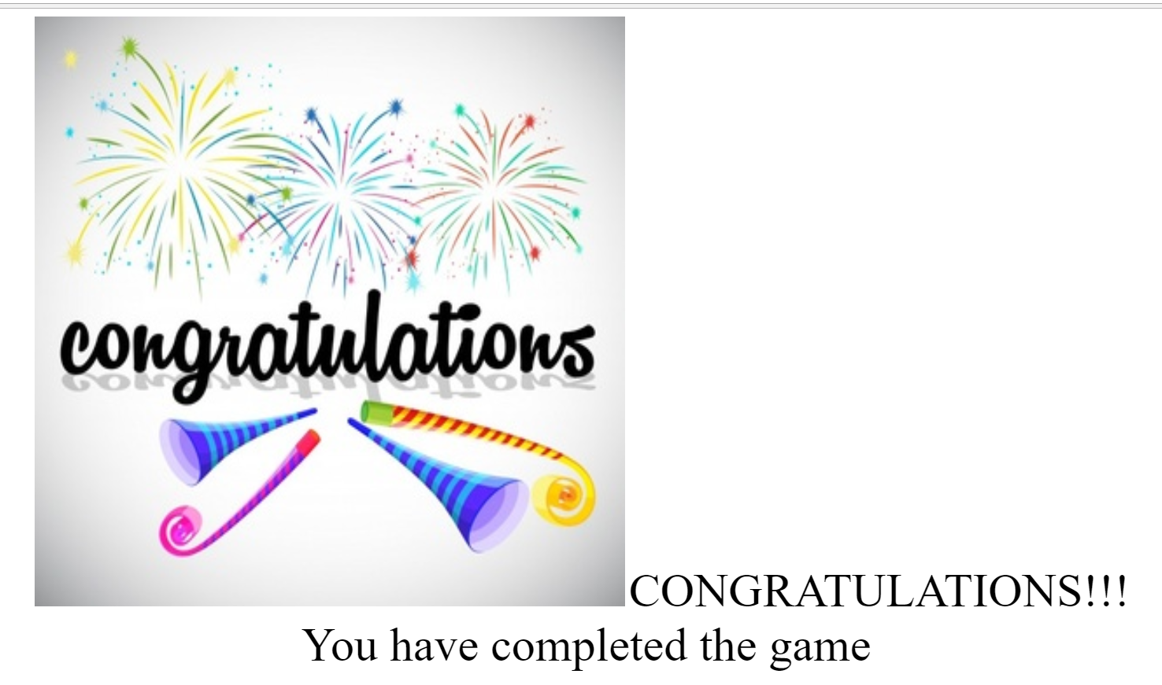

Appendix B: Flowchart for the App

Menu screen
Game speech screen
Game text screen
MCQ
Correct or Incorrect
Start (i=0)
Correct
Incorrect
While i<20
Else
Congratulations Screen

